**Many to Many**

* Many-to-Many relationship occurs when Many records of one table corresponds to multiple records in another table.

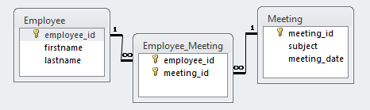

According to the relationship Employee can have any number of Meeting and the Meeting can have any number of Employee.

* **Using Mapping File:**

<class name="Employee" table="EMPLOYEE">

. . . .

. . . .

<set name="certificates" cascade="save-update" table="EMP_CERT">

<key column="employee_id"/>

<many-to-many column="meeting_id" class="Meeting"/>

</set>

</class>

* + The **<many-to-many>** element indicates that one Employee object relates to many Meetings and column attributes are used to link intermediate EMP_CERT.

**Using Annotations**

* The @ManyToMany annotation is used to create the many-to-many relationship between the Student and Course entities.
* The @JoinTable annotation is used to create the STUDENT_COURSE link table and @JoinColumn annotation is used to refer the linking columns in both the tables.